CURRICULUM VITAE
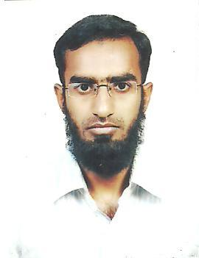

MOHAMMED AMEENUDDIN
# 7-129,
Near Saleha masjid, E-mail:Ameenuddin45@gmail.com
Marlu, Mobile: +91-9703232045.
Mahboob Nagar– 509001.

CAREER OBJECTIVES:

To aspire to challenging and dynamic position with my sheer hard work and contribute to the organization in best possible manner. I’ll look forward to work for an organization which merit of an employee and rewards performance.

ACADEMIC PROFILE:

Qualification | Name of the  Institution | Name of the University/board | Year of  Passing | % of  Marks
B.Pharmacy | Smt. Sarojini Ramulamma College Of Pharmacy, Mahboob Nagar. | Osmania University Hyderabad | 2008-12 | 66%
Intermediate | Bhavita Junior College,  New town, Mahboob Nagar | Board Of Intermediate Education, Hyderabad | 2006-08 | 91%
S.S.C | Nalanda vidyalaya high school, S.S Gutta, Mahboob Nagar. | Board Of Secondary Education, Hyederabad | 2005-06 | 86%

Work experience: Worked as hospital pharmacist at SAI SUMANTH HOSPITAL (MAHABOOBNAGAR) from December 2011 to February 2013.

TECHNICAL SKILLS:

• MS-office & internet concepts.

STRENGTHS:

1 Ability to handle multiple tasks take the initiative organized priorities.
2 Fast & self-directed learner, work effectively independently or as team player.
3 Capability to Work in any environment and in any condition.
4 Willingness to learn and belief in hard work.

PERSONAL PROFILE :

Name : MOHAMMED AMEENUDDIN

Date of Birth : 01th July, 1991

Nationality : Indian

Religion : Muslim

Gender : Male

Marital Status : Single

Languages Known : Hindi, Telugu, English

Hobbies : Playing Out Door Games

PASSPORT ID NO: K4733521

DECLERATION:

I hereby declare that the information given above is TRUE to my knowledge and I am
solely responsible for its accuracy.

(MOHAMMED AMEENUDDIN)

